OBJECT ORIENTED PROGRAMMING PROJECT PROPOSAL

ONLINE HOSPITAL APPOINMENT SYSTEM

# **OOP PROJECT PROPOSAL**

|  |  |  |  |
| --- | --- | --- | --- |
| Project Title | **ONLINE HOSPITAL APPOINTMENT SYSTEM** | | |
| **Abstract** | * Made a website by using FLASK * Use SQLALchemy for database * Design the website by using HTML * Made seven classes * Did inheritance, aggregation, over-loading, over-riding and polymorphism * PROBLEM: We usually face the problem of waiting for our appointment in hospital for hours which waste our precious time. * SOLUTION: So, we propose a solution to overcome this major problem so we design an appointment system which facilitate the patient by taking their time online at home and also calculate exact time so that he/she should arrive to hospital for check-up | | |
|  | **Roll No.** | **Name** | **Signature** |
| **1** | CS-18081 | **Areesha Mujahid** |  |
| **2** | CS-18053 | **Syeda Fatima Asim** |  |
| **3** | CS-18048 | **Syeda Fatima Ali** |  |

**Date of submission: 12th July 2019**

**INDEX**

|  |  |  |
| --- | --- | --- |
| **S.No.** | **Diagram Name** | **Page#** |
| 1 | Class Diagram | 3 |
| 2 | Inheritance | 4 |
| 3 | Polymorphism | 5 |
| 4 | Aggregation | 6 |
| 5 | Composition | - |
| 6 | Any other representation/modeling | 7 |

**CLASS DIAGRAM**

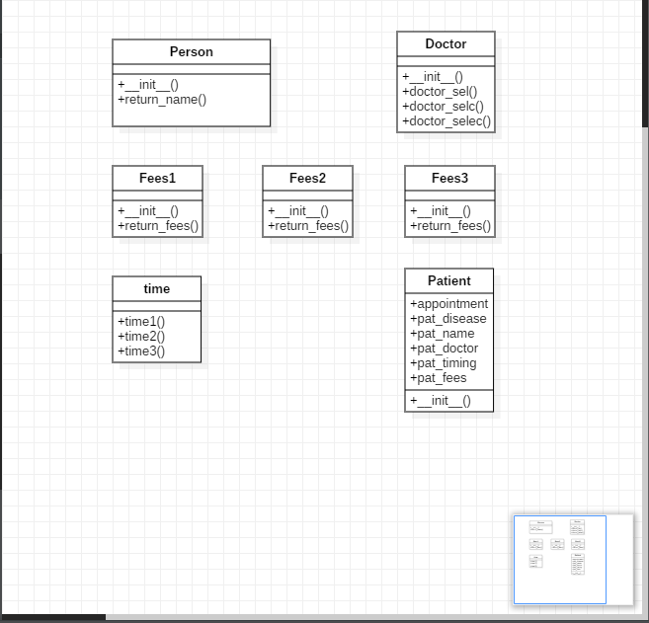

**INHERITANCE**

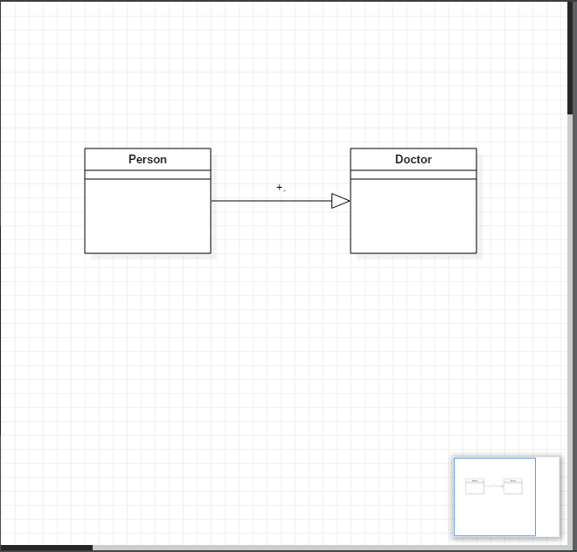

**POLYMORPHISM**

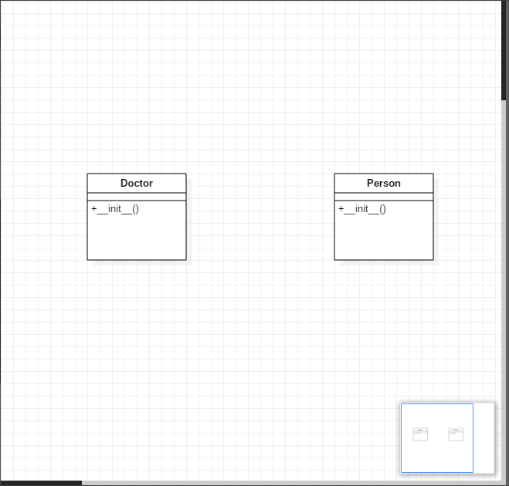

**AGGREGATION**

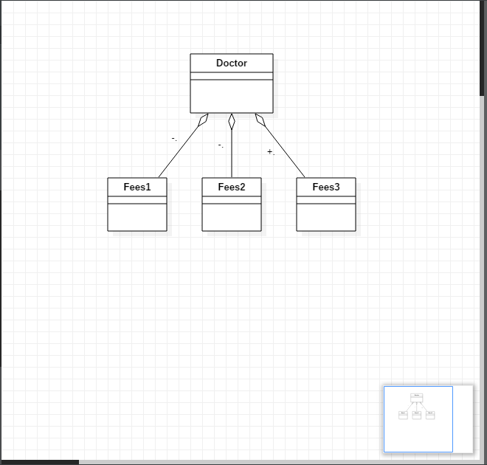

**REPRESENTATION**

